Summary basal attributes article

Main Message. The primary objective of the article is to determine how specific fundamental attributes, when systematically combined, are perceived—either negatively or positively (assessing valence)—in terms of accepting new material systems. This approach is tested through the evaluation of multiple textual descriptions of future material systems that are generated automatically.
Study Design. We are planning a study divided into several successive steps:

- reduce and translate existing basal attribute list; first reduce it independently (without surveying livMatS researchers); make sure that no too generic basal attributes are included (like "modern", "innovative", ...), which cannot be related to material systems

- within a world café the basal attribute list will be evaluated by experts; for each attribute ask (a) about importance for livMatS, (b) about valence [-3,3], further after evaluation participants can freely add further attributes (+ indicate valence) and in additional questions asked about

  - relevance of specific basal attribute for Research area (A, B, C, D)
  - missing important basal attribute for Research area (A, B, C, D)
  - Further livmats publication were automatically scanned for relevant adjectives

- main study with laypeople, here the respondents get the task to connect 32 basal attributes to the neutral “Akzeptanz eines neuen Materialsystems” concept in the center of the CAM and change the valence of the single basal attributes; further multiple subsequent questions are surveyed
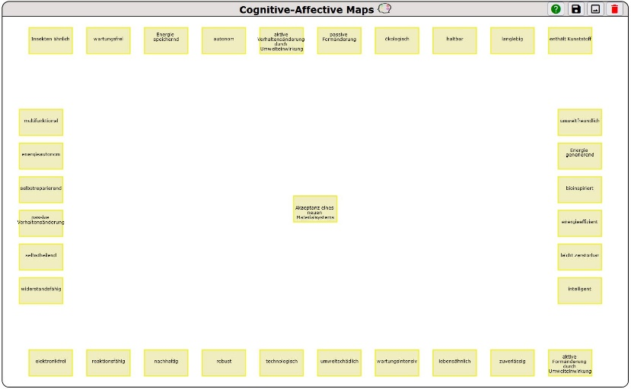
- Using (a) Large Language Model to generate textual descriptions of material systems based on 3. and (b) test textual descriptions by a scenario-based approach

